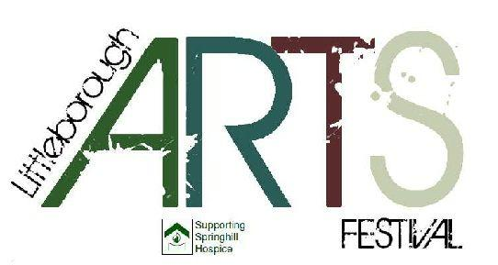

NEW

Hollingworth Lake
Makers Market
Sunday 21st 2018 October 11-4
Hollingworth Lake Rowing Club

For the FIRST time Littleborough Arts Festival are holding a Makers Market at the very popular Hollingworth Lake.

We are looking for food, art and craft producers in the area to exhibit
Admission is FREE for visitors but as a special offer for our first Market we are charging makers only £10 for a space or stall

We intend to produce a market of high quality goods with a variety of product

Hollingworth Lake is one of the most visited tourist attractions in Great Manchester and we expect high visitor numbers.
Refreshments will be available
There is easy Access from Smithybridge Station

Please note:- the event will be held upstairs with no disabled access. Unloading is available outside the venue and parking in the immediate area.

Applications are invited from makers, if you are interested please download the form below and return to
Makers Market Ebor Studios William Street, Littleborough
Or email to littleboroughartsfestival@gmail.com

Littleborough Arts Festival : Makers Market

Name
Business name (if applicable)
Type of work/product
Address
Tel No
Email Address
Website (if no website please enclose/attach 2 photographs of product)
Do you require 6ft table or a space. If larger than 6 ft please specify. | Yes | No | ?
Do you need electricity? We cannot guarantee electricity but will do our best | Yes | No
Are you prepared to be outdoors? | Yes | No
Short description of materials used
Do you attend any other makers markets if so which ones.

